- Open Microsoft Excel or Google Sheets, create a column named 'Order Amount', and enter 20 random numbers between 100 and 1000 to simulate Zomato order values for a day.
ANSWERS:
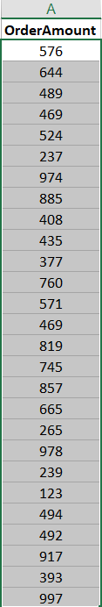

- From your 'Order Amount' data, calculate the mean, median, and mode using Excel or Sheets functions (AVERAGE, MEDIAN, MODE) and write the results below your data.
ANSWERS:
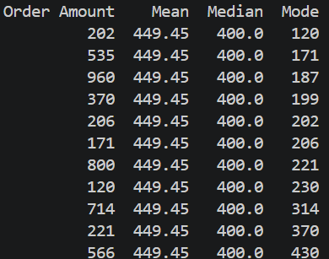

- Select the first 5 values from your 'Order Amount' column as a sample. Calculate the sample mean and compare it to the population mean you found earlier.
Hint: Use the AVERAGE function for both calculations and observe the difference between sample and population means.
ANSWERS:
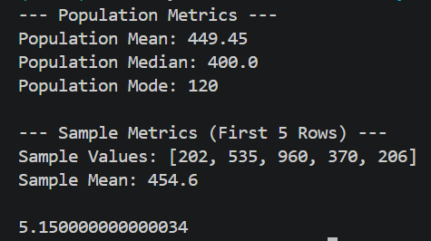

- Write a short paragraph explaining the difference between 'population' and 'sample' using your Zomato order data as an example. Mention which one is more practical to use for a food delivery company and why.
ANSWERS:
Using pandas, the true population mean of all 20 Zomato orders is calculated as 449.45. When taking a subset of just the first 5 orders, the sample mean comes out to 454.6. The sample mean differs from the population mean because a sample only captures a small fraction of the overall data. While it provides a quick estimate, it naturally misses the variation present across the entire dataset.

